2025 SPONSORSHIP PACKAGES
12th Annual Town of Dagsboro Christmas Parade
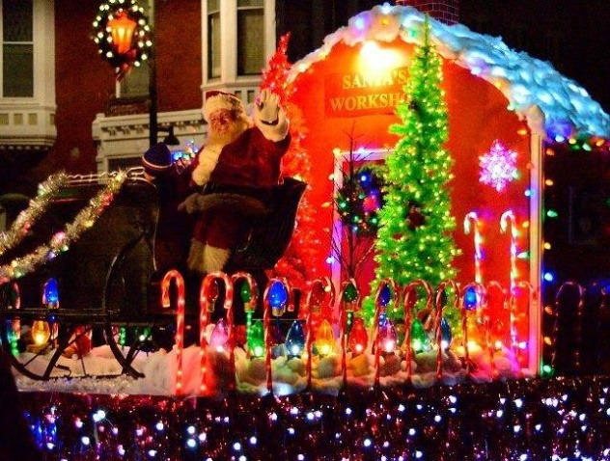
12th Annual Town of Dagsboro Christmas Parade
Tuesday, December 9, 2025 at 7pm
PRESENTING SPONSORSHIP (ONLY 6 AVAILABLE!) - $300.00
- Business listed as Presenting Sponsor on Town of Dagsboro Facebook page (with business logo) and all related media opportunities.
- Recognition by Parade Announcer as a Presenting Sponsor (4-5 times during Parade).
ASSOCIATE SPONSOR - $150.00
- Business listed as Associate Sponsor on Town of Dagsboro Facebook page (NO business logo) and all related media opportunities.
- Recognition during Parade by Announcer as Associate Sponsor (2 times during Parade).
DONATION - $100.00
- Business name listed as donor on Town of Dagsboro Facebook page (NO business logo).
- Recognition during Parade by Announcer as donor (1 time during Parade).
==================================================================================================
YES! Our Business would love to Sponsor the Dagsboro Christmas Parade! (Select One)

{ } PRESENTING Sponsor ($300) { } ASSOCIATE Sponsor ($150) { } DONATION ($100)

Business Name:_____________________________________________________________________________________

Address:___________________________________________________________________________________________

Contact Person:_________________________________________ Phone:_____________________________________

Please make checks payable to: Town of Dagsboro
Thanks for your support!
QUESTIONS? Please contact Town Hall - (302) 732-3777

